**WORKSHEET 3**

**Student Name: Priyansh Tyagi**

**UID: 20BCS5670**

**Branch: CSE**

**Section: 903-A MM (DWWC- 43)**

# Que-1: [Maximum Gap](https://leetcode.com/problems/maximum-gap/description/)

**Code:**

class Solution { public:

int maximumGap(vector<int>& nums) { sort(nums.begin(), nums.end());

int ans=0;

for(int i=0;i<nums.size()-1;i++){ if(ans<(nums[i+1]-nums[i])){

ans=nums[i+1]-nums[i];

}

}

return ans;

}

};

# Output:

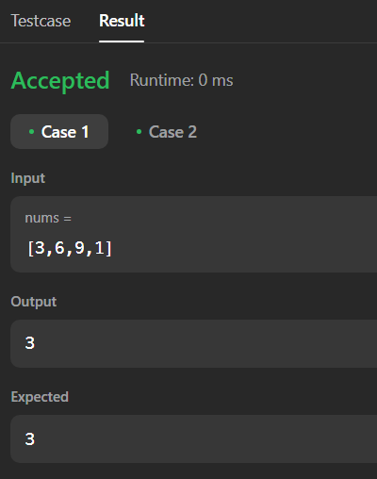

**Que-2:** [**Sort Colors**](https://leetcode.com/problems/sort-colors/) **Code:**

class Solution { public:

void sortColors(vector<int>& nums) { int start=0;

int end=nums.size()-1; int i=0; while(i<=end){

if(nums[i]==0){

int temp=nums[i]; nums[i]=nums[start]; nums[start]=temp; start++;

i++;

}

else if(nums[i]==2){ int temp=nums[i]; nums[i]=nums[end]; nums[end]=temp; end--;

}

else{i++;}

}

}

};

# Output:

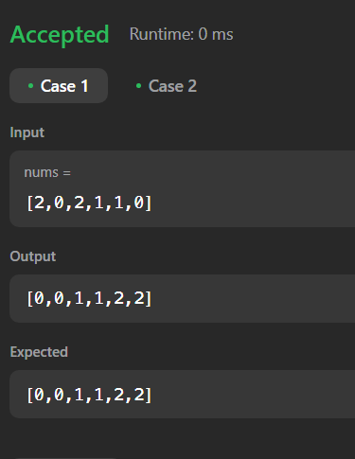

**Que-3:** [**Chef and Lockout Draws**](https://www.codechef.com/submit/LOCKDRAW?tab=statement) **Code:**

#include <iostream> using namespace std;

int main() {

int t; cin>>t; while(t--){

int a,b,c; cin>>a; cin>>b; cin>>c;

if(a>b and a>c){ if(a==b+c){

cout<<"YES"<<endl;

}

else{

cout<<"NO"<<endl;

}

}

else if(b>a and b>c){ if(b==a+c){

cout<<"YES"<<endl;

}

else{

cout<<"NO"<<endl;

}

}

else{

if(c==a+b){ cout<<"YES"<<endl;

}

else{

cout<<"NO"<<endl;

}

}

}

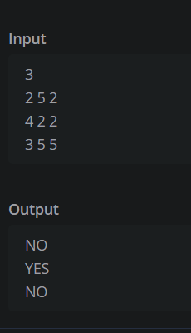

# Que-4: [Turbo Sort](https://www.codechef.com/submit/TSORT?tab=statement)

**Code:**

#include <bits/stdc++.h> using namespace std;

int main() {

// your code goes here int t;

cin>>t;

vector <int> a(t); for(int i = 0; i< t ; i++){

cin>>a[i];

}

sort(a.begin(),a.end()); for(int x : a)

cout<<x<<endl; return 0;

}

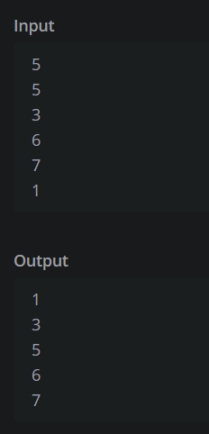

# Que-5: [Reorder Data in Log Files](https://leetcode.com/problems/reorder-data-in-log-files/description/) Code:

class Solution { public:

vector<string> reorderLogFiles(vector<string>& logs) {

auto it = stable_partition(logs.begin(), logs.end(), [](const string& str) { return isalpha(str[str.find(' ') + 1]);

});

sort(logs.begin(), it, [](const string& str1, const string& str2) { auto substr1 = string(str1.begin() + str1.find(' '), str1.end()); auto substr2 = string(str2.begin() + str2.find(' '), str2.end()); return (substr1 == substr2) ? str1 < str2 : substr1 < substr2;

});

return logs;

}

};

# Output:

